Security:
-> Access Rights – control over crud operations
ir.model.access
-> Record rules – define record level access rights
ir.rule

Groups → assign record rules / access right
→Field , view , Menu , Actions , More level rights
Types of groups
→ Individual → technical points ,
technical groups are available fo
→Multi Level

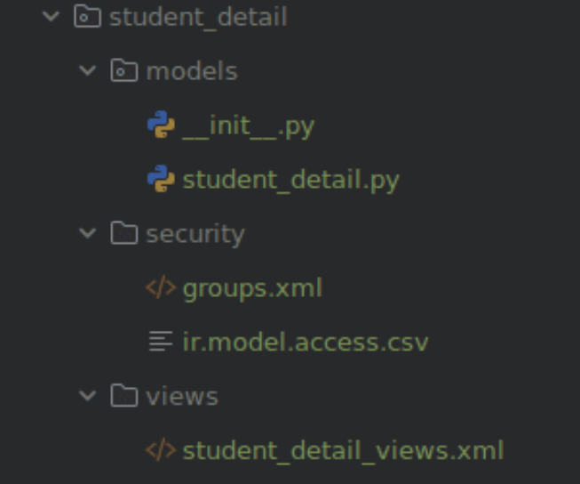
## Access Rights :
Method 1: ir.model.access.csv:

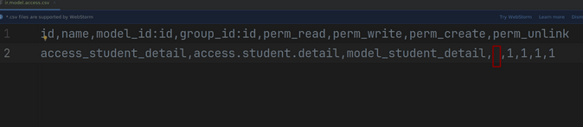

id,→ unique name access_xyz_xyz
name, any human readable name and write using dot → access.student.details

model_id:id, target model id used model_xyz_xyz
----------------→module.model_xyz_xyz_xyz

group_id:id, → A reference to the external ID of the security group to which the access rights are granted. If this field is left empty, the access rule applies to all users (global access). , , → means empty basicllly for all user

perm_read, → 0,1 for read

perm_write,-→0,1 for update

perm_create,-→0,1 for create

perm_unlink-→0,1 for delete

#perm means → permissionn

Method 2: security_access_data.xml
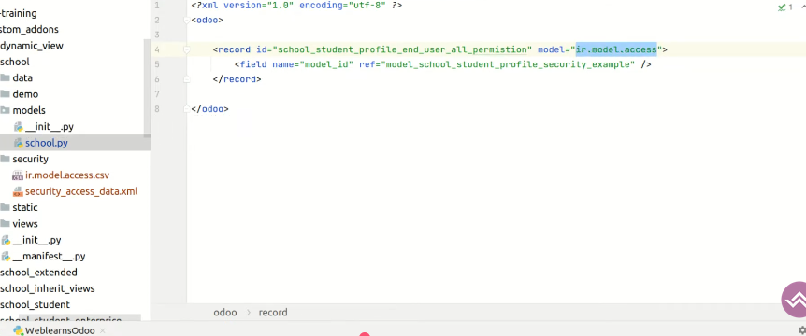
id → its use for uniques name ,
model → use ir.model.access for the security in it

its a one2many field so use the reference as a many2one field in it

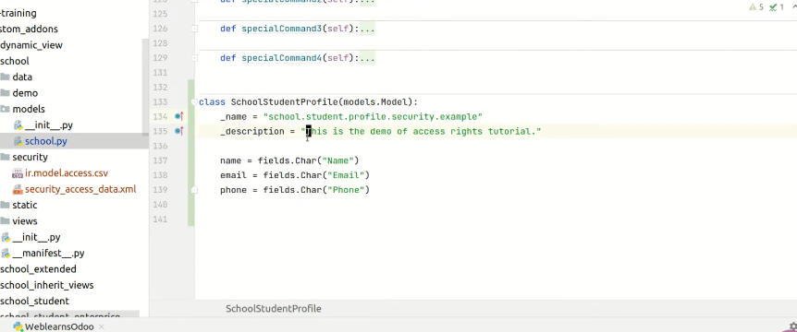
model
Models:

A model is a class that corresponds to a data relation. It will have all of the relevant fields and behaviours for the data you will be storing

There are three types of models:
- Models
- Abstract Model
- Transient Model
model name m humesha filename ko likhna chaiye import me
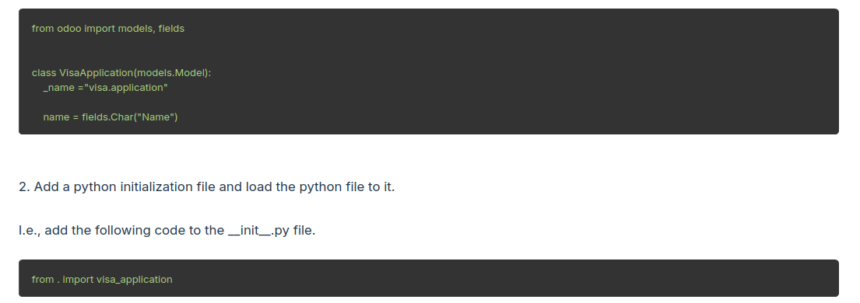
→manifest me humesha views file jo bhi hoga models ka usko store krte h in the data “ ”.

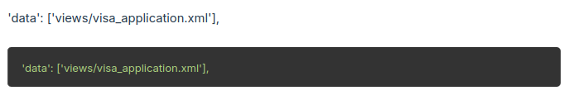

→ Actions :

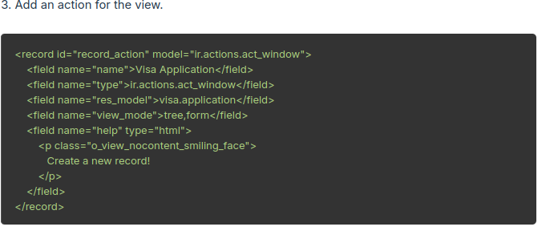
name → action’s name
type →model actions name
res_model → that class model name write here like in my customs model estate.property.offer

Types of menu:-

1. Root Menu
2. First level Menu
3. Actions Menu

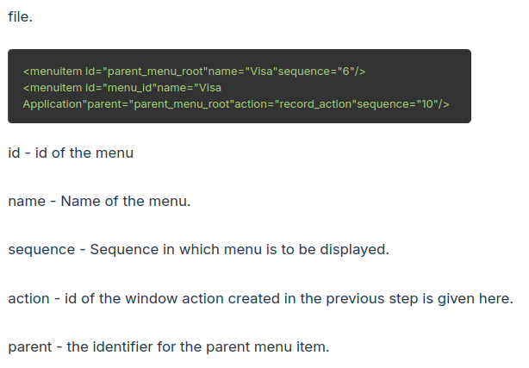
→ menu - but used as a menuitem in xml

→menu item → same as menu in this all the things are presented in this
id
name
sequence
parent
actions

Field Attributes :
Attributes are properties. Every object has some attributes. In Odoo, each model, field, etc., has some properties that are attributes. In this section, we will go over some model attributes.
1. String :-name = fields.Char(string="Field name")
"name" refers to the variable name, "Char" refers to the field type, and string refers to the attribute. String values are always surrounded by single or double quotes. This value will be displayed on the UI.
2. Help: the tooltip of the field seen by users
3. requied -bool whether the value of the field is required (default: False)
4. char – 1. size – used for the max size of it (int)
2. trim -(bool) used as remove the whitespace and underscore if true
5. float →
6. Int →
## Advanced Fields:
1. Binary:-
import base64
binary_file = fields.Binary('Binary File')

2 . HTML FIELD :
html_file = fields.Html(string="Html File " , help="html field is created")

3. Image FIELD : mage_file = fields.Image(max_width = 5 , max_height=10)
max_width (int) – the maximum width of the image (default: 0, no limit)
- max_height (int) – the maximum height of the image (default: 0, no limit)
4. Monetary field:
currency = fields.Monetary(string="Fee",currency_field="curr_id")
curr_id = fields.Many2one('res_currency',string="curr id" , invisible = True )

for the monetary field a currency field is mandotary and it is many2one is created it .

5. Selection Field:
person_gender = fields.Selection([
('male',"Male"),
('female',"Female")
],string="Person's Gender" , help="Enter Your Gender")

for the selection field two things were defined in tuple (‘backend’,’frontend’)

6. Date :
A date or datetime object.
- A string in the proper server format:
- YYYY-MM-DD for Date fields,
- YYYY-MM-DD HH:MM:SS for Datetime fields.
- to_date() will convert to a datetime.date
- to_datetime() will convert to a datetime.datetime.

Relational field:
1. Many2One:
odoo.fields.Many2one
The value of such a field is a recordset of size 0 (no record) or 1 (a single record).
Parameters
- comodel_name (str) -- name of the target model Mandatory except for related or extended fields.
- domain -- an optional domain to set on candidate values on the client side (domain or a python expression that will be evaluated to provide domain)
- context (dict) -- an optional context to use on the client side when handling that field
- ondelete (str) -- what to do when the referred record is deleted; possible values are: 'set null', 'restrict', 'cascade'
- auto_join (bool) -- whether JOINs are generated upon search through that field (default: False)
- delegate (bool) -- set it to True to make fields of the target model accessible from the current model (corresponds to _inherits)

auto_join=True when:
- You often filter or search records using fields from a related model.
- You want to improve performance in large datasets.
- You’re building custom modules where speed is important in list views or filters
2. One2Many:
odoo.fields.One2many[source]
One2many field; the value of such a field is the recordset of all the records in comodel_name such that the field inverse_name is equal to the current record.
Parameters
- comodel_name (str) -- name of the target model
- inverse_name (str) -- name of the inverse Many2one field in comodel_name
- domain -- an optional domain to set on candidate values on the client side (domain or a python expression that will be evaluated to provide domain)
- context (dict) -- an optional context to use on the client side when handling that field
- auto_join (bool) -- whether JOINs are generated upon search through that field (default: False)

4. Command:
odoo.fields.Command is a Python class used to manage data manipulation in relational fields (One2many and Many2many) in a clean, readable, and object-oriented way.
Syntex:
(command, record_id, values)
in some cases:
(command, record_id)
(command, 0, values)

Pseudo Relational Field:
1. reference Fields:
A reference field will help to create a dynamic relationship in a model, Which means we can select the model dynamically to create the relation.
For example, in a Sale Order, if we create a Many2one field for customers, it will only create a relation between these two models, here we pre-define the target model that is customers.
source_document = fields.Reference (selection = [('sale.order', 'Sale Order'),
('purchase.order', 'Purchase Order'),
('account.move', 'Invoice')],
string = "Source Document")
reference_field = fields.Reference(selection=[('estate.property', 'Property')],string="Property Postcode Id")
for the reference field used as a selection field in it and in after select that thing so we were refer the particular fields and all the field of that model
The field value is stored as a string following the pattern "res_model,res_id" in database.

Comuted Fields:
there are fields whose values are calculated based on other fields, either within the same records or in related records.
Computed fields dynamically calculate values at runtime and are not inherently writable or searchable unless explicitly configured.
For the field of compute doesnot write outside that fields
its were write inside the parameter in it and we use compute=’_compute_field_name’
Computed fields are readonly by default. To allow setting values on a computed field, use the inverse parameter.

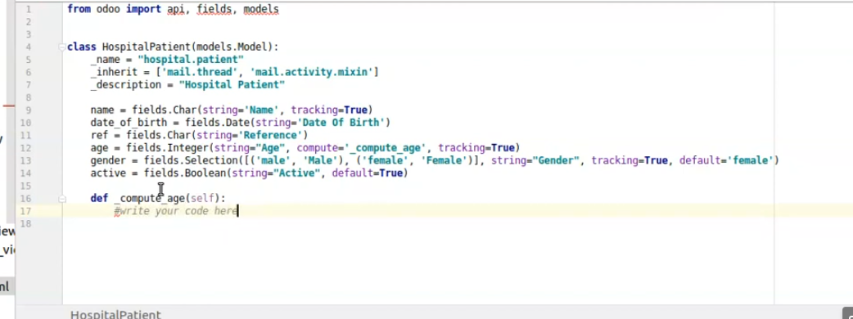
@api.depends('date_of_birth')
def _compute_age(self):
for rec in self:
today= date.today()
if rec.date_of_birth:
rec.age = today.year - rec.date_of_birth.year
else:
rec.age = 0

depends means if we use @api.depends(‘field_name’) so its means any change In the fieldname so that particular compute function excute . But at a same not use so that compute function were excutated at the time of save .
And by default compute field is non storeable in database so if we store in database so we use store=True

inverse parameter : An inverse function is a method that is called when the value of a calculated field changes. The role of the inverse function is to ensure the values of the fields on which the calculated field depends are updated, thus maintaining the accuracy of the calculated field's returned value.

For the inverse parameter is used because compute is a readonly field so that create a problem so making a working field so we use inverse paramerter and define that function of it and by that we define the things and calcluate the things on it.
def _inverse_age(self):
for rec in self:
today= date.today()
if rec.age:
rec.date_of_birth = date(today.year - rec.age, today.month, today.day)
else:
rec.date_of_birth = False

# Scaffold command:
It is the process of creating a skeletal structure for a module in Odoo.

./odoo-bin scaffold module_name folder_name

module_name → means the module which custom create
folder_name → means where we set the things

if you directly work according to the the command so the folder create into a main odoo file but if we use to create the folder into a custom_addons so use the relative path of it

# Data Fields:
A model represents the structure or blueprint for different types of data objects or entities. A model is a class that contains all of the fields along with actions for the data you want to store, and it translates to the data relation (table)

Buttons:
two types of button is action and object

